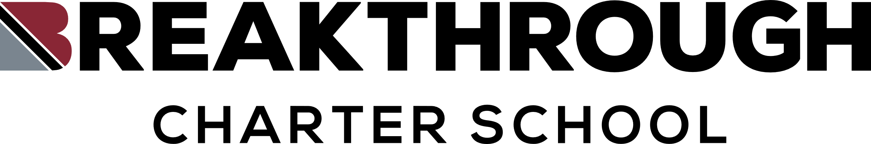

**AGENDA**

Regular Board Meeting

Breakthrough Charter School

April 30, 2025

1. Call to Order
2. Roll Call
3. Adoption of Agenda
4. Action Items
   1. Approval of Last Meeting Minutes
   2. Approval of February and March Financials
5. Superintendent Report
6. Adjourn